FFA ALUMNI TAILGATE

Friday, Sept. 27, 2019
At the football field
Before the Fairbury vs. Aurora game

Serving from 5:30-7:00 p.m.

COME ENJOY!
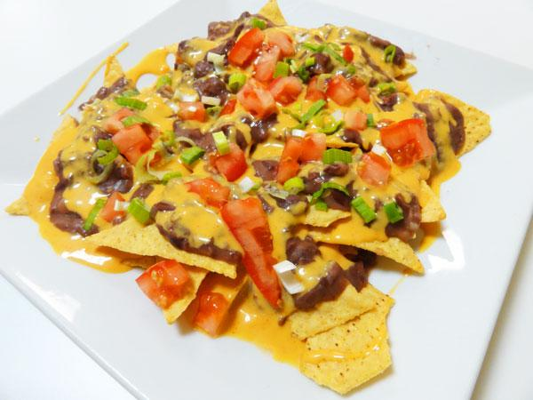

Nacho Bar
Complete with your choice of toppings including meat, tomatoes, olives,
sour cream, lettuce, jalapenos & salsa.

Plus
Dessert & Drink

All for only---$5.00

*Money raised is used to help support the Fairbury FFA chapter.
